Module 2 Activity
William Pascoe
CYB-220: Network Security
Jonathon Schumaker
November 7, 2025

Network Topology
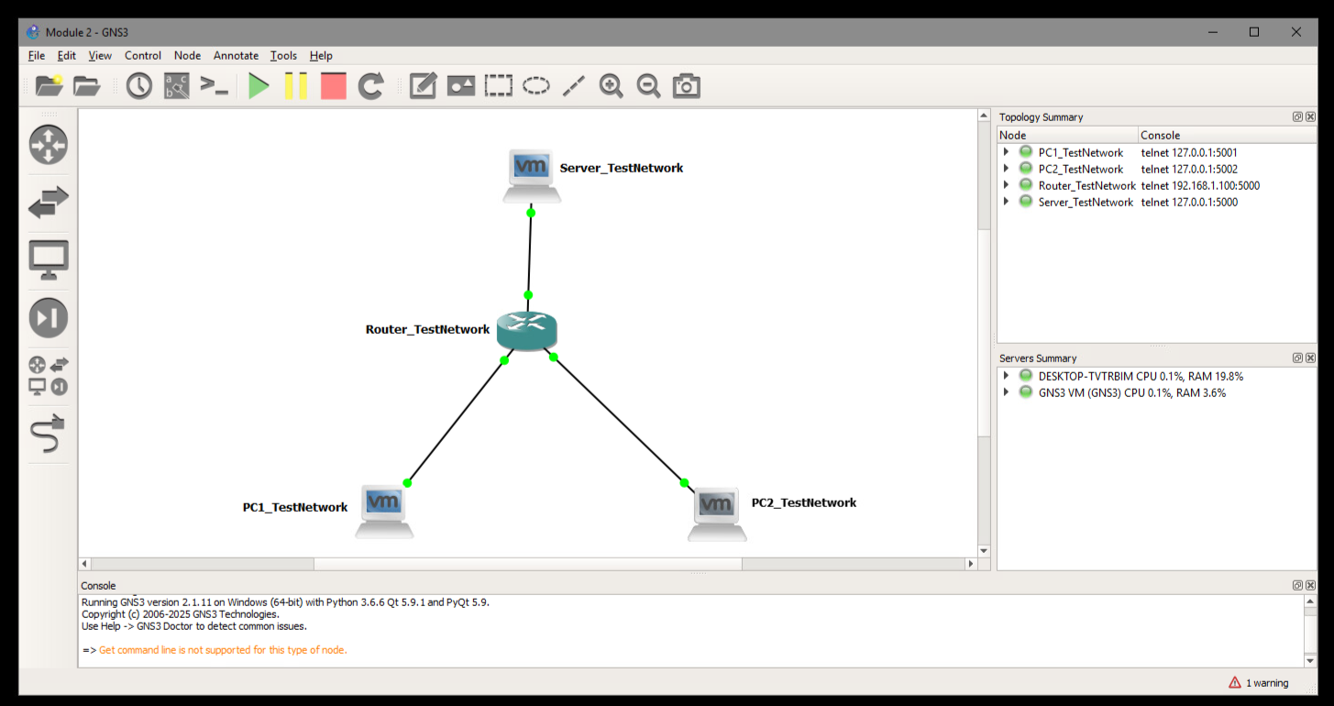

Ping PC1_TestNetwork to PC1_TestNetwork
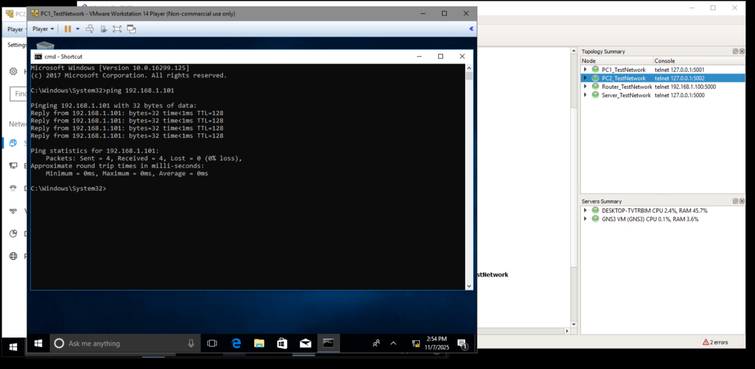

Ping PC1_TestNetwork to PC1_TestNetwork Gateway
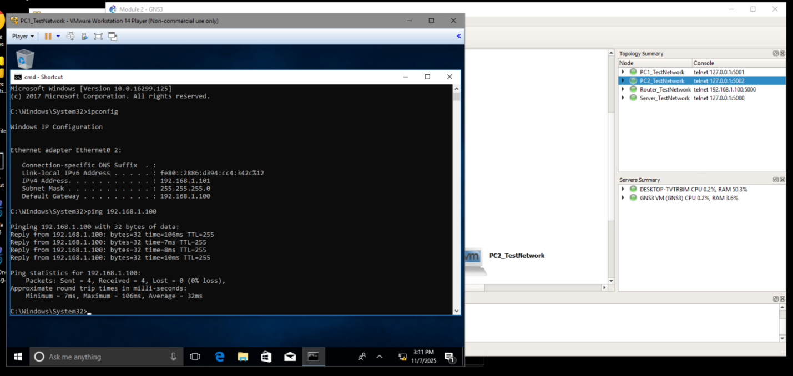

Ping PC1_TestNetwork to PC2_TestNetwork Gateway
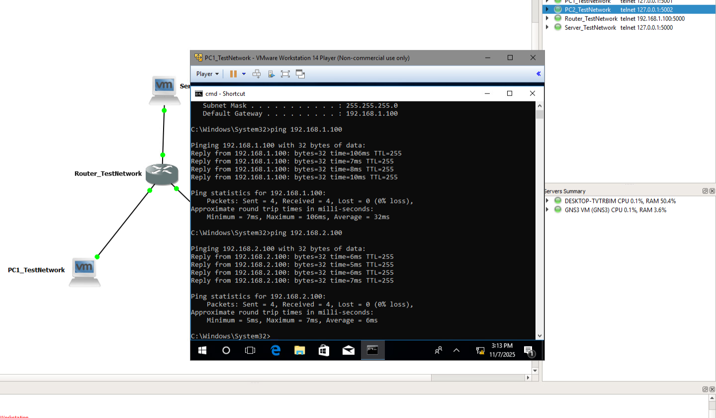

Ping PC1_TestNetwork to PC2_TestNetwork
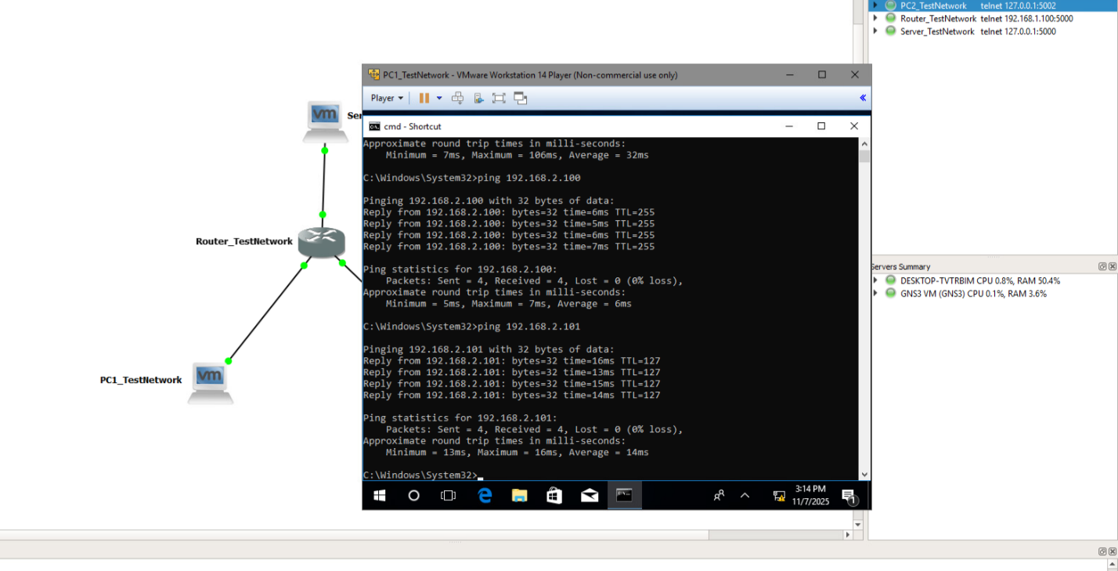

Ping PC2_TestNetwork to PC1_TestNetwork
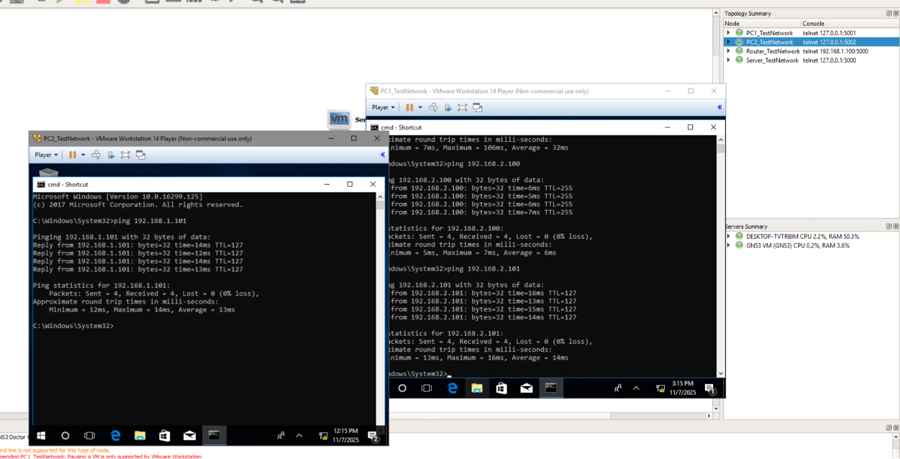

Ping PC2_TestNetwork to Server_TestNetwork
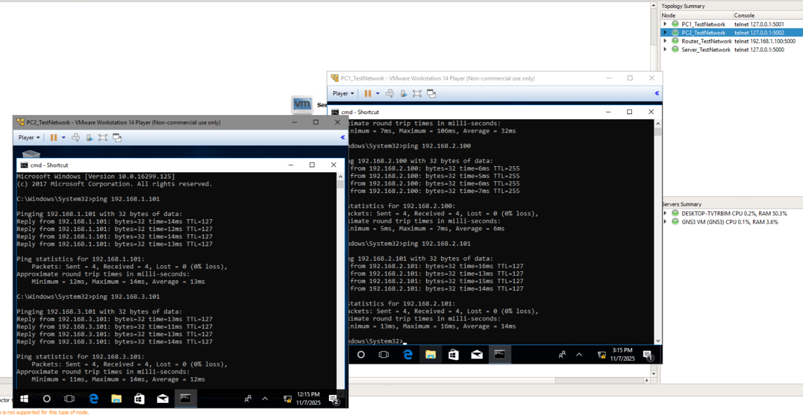

Ping Server_TestNetwork to PC1_TestNetwork
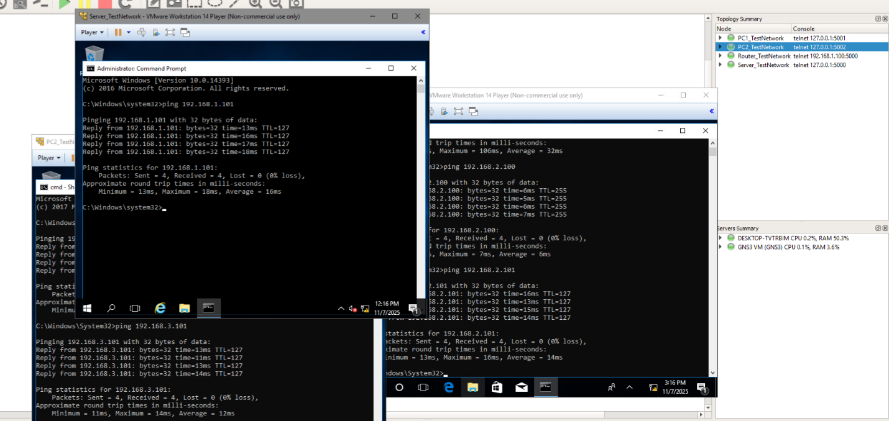

Ping Server_TestNetwork to PC2_TestNetwork
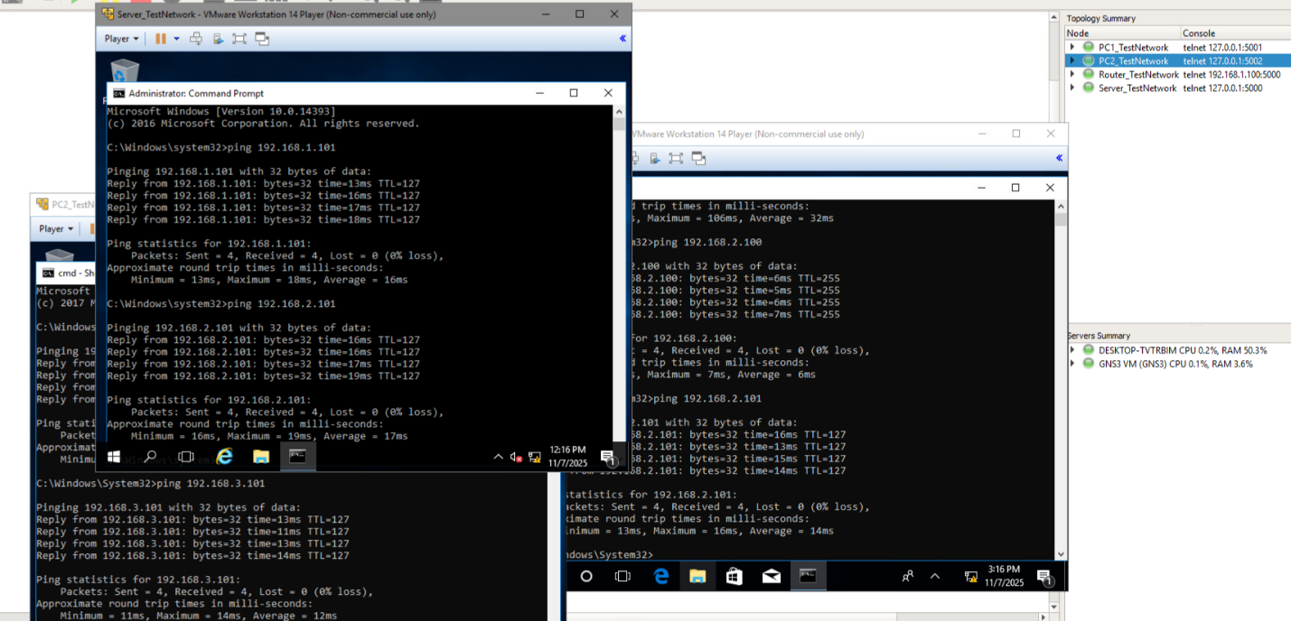

Ping PC1_TestNetwork to Server_TestNetwork
